**A picture containing clipart

Description generated with very high confidence**

CREATING A DOCKERFILE

DevOps Certification Training

[**support@intellipaat.com**](mailto:support@intellipaat.com)

**+91-7022374614**

**US: 1-800-216-8930(Toll Free)**

**CREATING A DOCKERFILE**

**Step 1:** First, create a folder docker, in the home directory

$ mkdir docker

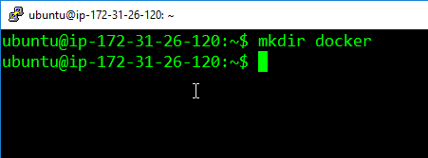

**Step 2:** Enter into this directory, and create a file called ‘Dockerfile’, with the same contents as the Sample Dockerfile. Add the following content in the Dockerfile.

$ cd docker

$ sudo nano Dockerfile

FROM ubuntu

RUN apt-get update

RUN apt-get -y install apache2

ADD . /var/www/html

ENTRYPOINT apachectl -D FOREGROUND

ENV name Devops Intellipaat

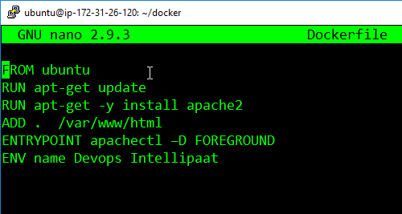

**Step 3:** Create one more file called, index.html with the following contents can verify the push on DockerHub.

$ sudo nano index.html

<html>

<title> Sample Website </title>

<body>

Hello World

</body>

</html>

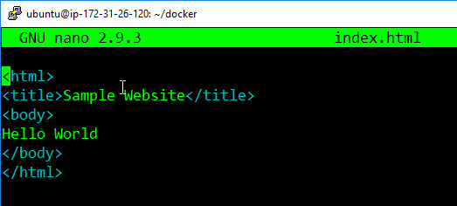

**Step 4:** Now pass the following command

$ docker build <directory-of-dockerfile> -t <name of container>

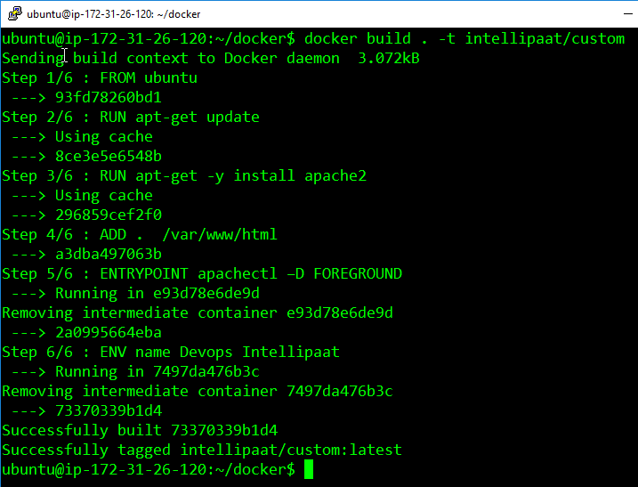

**Step 5:** Finally, run this built image, using the following command:

$ docker run –it –p 81:80 –d <name of container>

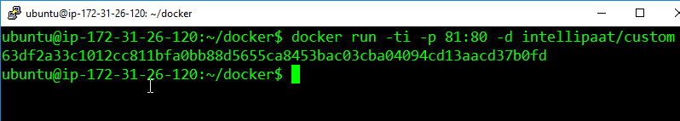

**Step 6:** Now navigate to the server IP address on port 81

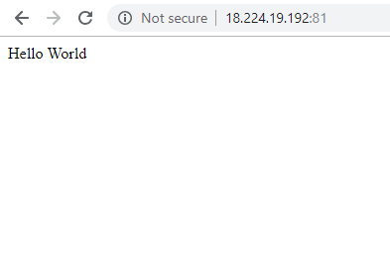

**Step 7:** Finally, login into the container, and check the variable $name, it will have the same value, as given in the Dockerfile.

